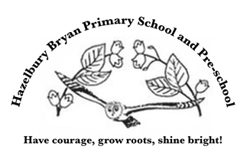

Hazelbury Bryan Primary School

Code of Conduct for Remote Learning

Dear parents,

We are really looking forward to seeing you all back at school. In the meantime, please read the guidelines below for any remote learning. These will be shared with the children upon their return. Google Classroom will continue to be used for homework and for any future school closure.

When working on Google Classroom I agree to the following:

- I understand that my log in details should be kept safe and secure and not shared with anyone else.
- I will only use Google Classroom as directed by my teacher and will only type in or upload material related to my learning.
- I will only use the chat facility to send messages related to my learning.
- When working from home, I will complete my work in a quiet, safe environment free from distractions.
- I will respect my friends and adults during remote learning in any comments that I make or work I produce.
- If working from home, I will complete tasks on time.
- Any photographs or videos will be done fully dressed and will not include others from my household. These must also be created in a room downstairs, never in a bathroom or bedroom.
- Remember that when using social media, if you type something ‘it is always there, and you cannot take it back’. Be very sensitive and careful with what you type online.

If you have any questions, please feel free to get in touch anytime. We are here to support you whether you are currently in school or learning from home, anytime.

Your child’s class teacher is available for help and support via Google Classroom but please remember that they are working in school as well as providing remote learning for the children at home. It is a busy and unusual time in school and I ask that you consider their current workload. Please only contact them when necessary and regarding home learning. All other enquiries should be made via the school office.

Yours faithfully

Mrs K Waring

