SCHOOL NEWS - 14th October 2022
Value of the month: Courage

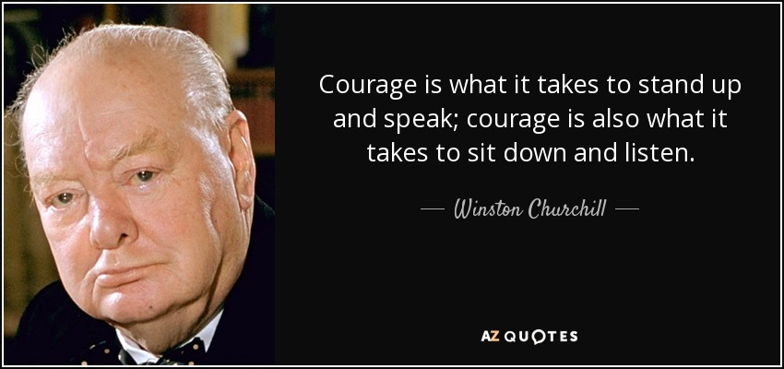
This week we welcomed Harrison into Hawks. Welcome Harrison, we look forward to getting to know you.
Community Jumble Sale  We will be holding a jumble sale here at Hazelbury Bryan Primary School on Saturday 29th October. Your child will be coming home with an empty bag tonight. If you are having a clear out, please fill your bag with any quality clothing, brick a brack, toys or books  Please drop the full bags to school on Fri 21 Oct during the school day or Friday 28 Oct between 10 - 12.  Unsold clothing will go to Bag2School on Thursday 3 November. |  | Houses  We have placed the children into houses in preparation for future sporting events and team activities within school. We will ask your child to wear a t-shirt in their house colour for sporting events in future. Further details to follow via class teachers. Siblings have been placed in the same house.
PTFA
Thank you to those that attended our PTFA meeting on Tuesday evening.
Please book Halloween Disco tickets via School Spider before midday Wednesday 19th October. Tickets include unlimited drinks and a hot dog. There will be a disco, fun and games. Pocket money items available such as tattoos, glitter tattoos, sweets, cakes and glow sticks. Barn Owls, Owls and Kestrels need to meet in the hall at 3.30pm and be collected at 4.30pm promptly so we can clean up and prepare for the next group. Parents of nursery children must stay with their little ones. Children in Hawks and Eagles should arrive at 5pm and be collected at 6.30pm promptly. Please arrive at the main school door to drop your child/ren off and collect via the fire exit at the side of the hall. A spooky evening awaits you!

In order for future PTFA events to go ahead, we will need to fill vacant positions such as Chair and Treasurer. You will be supported by a fantastic team. If you are able to assist us in our fund raising projects please contact myself, via the school office, or Anna Griffin as Vice Chair.
Lollipops  Due to a previous choking case in a primary school, we would prefer not to give out lollipops in school. Thank you for your understanding. | Piano Lessons  We are very fortunate to have Kingsley coming into school to offer piano lessons to the children during the school day. He currently has a few spaces available, if your child would like to learn the piano please contact him directly on: k.mcgregor1993@hotmail.com
Achievements
Learners of the week:
Barn Owls: Atticus for being a kind and caring friend and Arthur for fantastic enthusiasm in maths and his understanding of colour sorting.
Owls: William for his excellent effort in phonics.
Kestrels: Monty for writing a great persuasive letter.
Hawks: Amelia for always remaining focused on her learning.
Eagles: All of Eagles for their exceptional behaviour and inquisitiveness on their trip to Launceston Farm.
Other achievements:
James S was awarded the following cub badges: athletics plus, backwoods cooking, DIY, damboree cubs 2022, entertainer, fire safety and nights away. Phew what a lot of badges, well done James.
Swimming Awards:
Catherine received her 10 metres badge, Lia was awarded her 25 metres award and Aaron has passed his Goldfish 2 level. Fantastic swimming!
Children in Need  Theme this year: ‘Together we can change young lives’. On Friday 18th November we will celebrate Children in Need. Children are welcome to come to school in spots or yellow clothing. No uniform or money needed. We will be creating pieces of ‘spotty’ artwork throughout the week and will hold an art gallery after school on Friday 18th November. Year 5 will create their masterpieces before their trip to Leeson House. Families are welcome to come and purchase any of the artwork displayed. Monies raised will go to this wonderful charity. We will be holding many fun activities throughout the day. | Eagles School trip  Children in Eagles attended Launceston Farm on Wednesday to link with their DT and Geography topics of Food and the Environment. They even got to make pizzas! The sun was shining and the children were all a credit to you and our school. I received the following email soon after their return:  Good Afternoon Mrs Waring  I have just had the delight of hosting Eagles class on a visit to the Farm and I had to write to tell you how impressed I was both with their level of knowledge and eagerness to learn. Their listening skills were excellent; they were organised and responsive and asked some fantastic questions. My only regret is that their visit was over so quickly!  Well done Eagles, I am very proud of you.
Lost Property  Our lost property box is still full. Please come and browse items if your child is missing anything. I have popped the box in the main entrance for easy access. Please can you also check items at home as some items are still missing and may have gone to the wrong home. | Drop off  It has been brought to my attention that, on occasion, families are waiting at the gate in the morning, which is a road safety issue on these narrow lanes and being so close to a junction. Just a reminder that school starts at 8.45am. Children are welcome to come to school from 8.30am, if they wish to do the daily mile before class. I will endeavour to open the gate a few minutes earlier but please do not leave your child on the playground until an adult is out on duty (come on in with your child away from the road).
School Photographs
Please ensure that your child wears their full school uniform on Tuesday 1st November. P.E will not take place on this day. Jumpers and cardigans are needed due to the background colour. Pre-school, please be on time for your session this day as you will be first. If your child is not due in on a Tuesday you are more than welcome to bring them to the school hall at 9am promptly.
Attendance
Remember, each week the winning class gets placed into a draw. The more times you are in the draw, the more chance you have at being pulled out of our half termly draw to win a treat afternoon of their choice. Who will win next week?
Class: | Week beginning 10 October:
Owls | 95%
Kestrels | 97.4% - Well done Kestrels
Hawks | 95.6%
Eagles | 93.1%
Dates for your diary:
Friday 21 October - Break up for half term
Friday 21 October - Halloween Disco after school (PTFA event)
Saturday 29 October - Community Jumble Sale in school hall 10am
Monday 31 October - Return to school
Tuesday 1 November - Individual Photos Fraser Portraits, am
Thursday 3 November - Bag2School collection 9.00am
Wednesday 9 November - Whole School Flu Immunisation
16 - 18 November - Year 5 Residential at Leeson House
Friday 18 November - Children in Need fun day
Friday 18 November - Anti Bullying assembly for parents 2.30pm
Thursday 24 November - Family Link Worker, Sandie Brown, available for support for families 9.00am - 12.00pm
Friday 25 November - Church Thanksgiving Service 9.15am, all welcome
Saturday 3 December - Christmas Fayre 11am - 2pm (PTFA event)
Monday 5 December - Christingle Service in Church 2.30pm, all welcome
Tuesday 6 December - Christmas Nativity Dress Rehearsal for school and grandparents 2.00pm
Wednesday 7 December - KS1 & EYFS Christmas Nativity for parents 4.00pm
Thursday 8 December - Christmas Jumper Day
Friday 9 December - KS1 & EYFS Christmas Nativity for parents 9.30am
Wednesday 14 December - LFL Christmas Lunch
Wednesday 14 December - Open afternoon 1.30pm
Wednesday 14 December - Parents’ evening 3.15pm
Friday 16 December - Last day of the autumn term
Have a lovely weekend.
Mrs Waring and all staff at Hazelbury Bryan Primary School.

